Contents
1 Background: the urgency 2
2 Vision: what we want to achieve 2
3 Our solution: what we are developing 2
4 What differentiates our solution from others 4
5 Roadmap: deployment plan 5
6 Respective contributions 5
7 IP generated 6
8 Additional collaborators 7
9 Target obejctives & success metrics 8

Background: the urgency
A mismatch between old energy market mechanisms on one hand, and rapid advancements in renewable technologies on the other, has resulted in tremendous market inefficiencies.
EU, US and India alone will spend USD 220 billion between now and 2040 – if we do not introduce new, efficient markets.
Industry leaders have voiced concern. Specifically, they have called for efficient pricing and markets as a tool to better align energy demand and supply on a decentralized (or distributed) level.

Vision: what we want to achieve
To be the leading provider of pricing and market mechanisms for distributed energy markets.

Our solution: what we are developing
Platts and Blocklab Port of Rotterdam are jointly collaborating on a solution – an efficient, intelligent market designed to:
- Maximise utilisation of renewables;
- Incentivise flexibility of demand and supply.
Our combination of deep market expertise and technology experience puts us in a position to deliver a uniquely valuable solution to the industry.
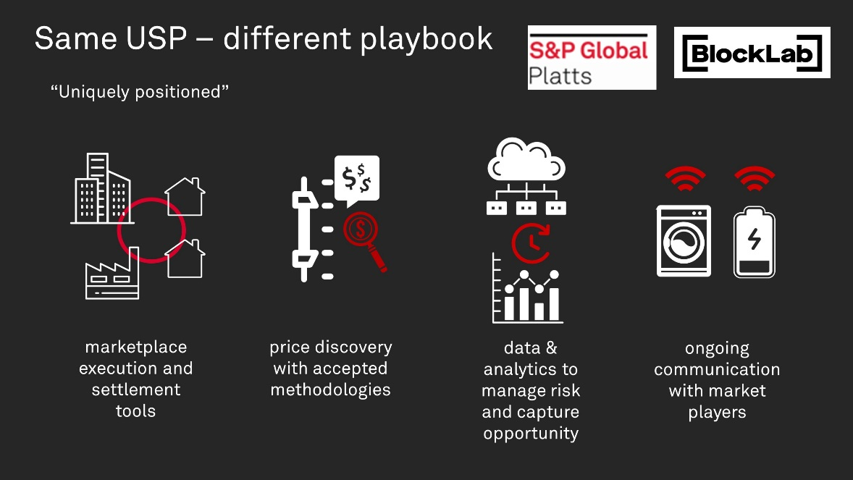
The solution has four components:
- Marketplace execution and settlement tools
  - There is currently no market on the distribution level (commercial/residential). There needs to be a marketplace that enable community energy trading. For example, it should allow commercial solar to be sold directly, at better rates, to other commercials or residential participants.
  - Settlement must be capable of handling microtransactions as commercial and residential usage is much smaller than industrial (wholesale).
  - Settlement is to be done without a central counterparty, to be efficient.

  - What we have done:
- Blockchain based marketplace that enables secure decentralized forward trading and settlement, and enforces market rules (see next page for details).

Specific functionalities of the blockchain based marketplace
- Money wallet (€-tokens) and energy wallet (KwH-tokens) for each user;
- Orderbooks for 192 forward markets (15 min/PTU) in which users can trade simultaneously;
- Smart contracts:
  - Atomic execution for each match;
  - Secure registry of user’s positions in each PTU;
  - Calculation and consolidation of user’s balances at the end of each PTU;
  - Enforcing the market rules, to ensure safety and regulations;
- Oracle function for smart meters;
- Handles both fixed and dynamic prices from energy suppliers via their own API;
- API with specific functions towards specific roles:
  - for agents to connect to the market;
  - for Market Regulator / Grid Operator: insight in the micro-grid
  - powering the dashboard of the user;
- Relayer function enhancing speed and efficiency of transaction handling;
- Secure payment environment via ABN AMRO sandbox environment.

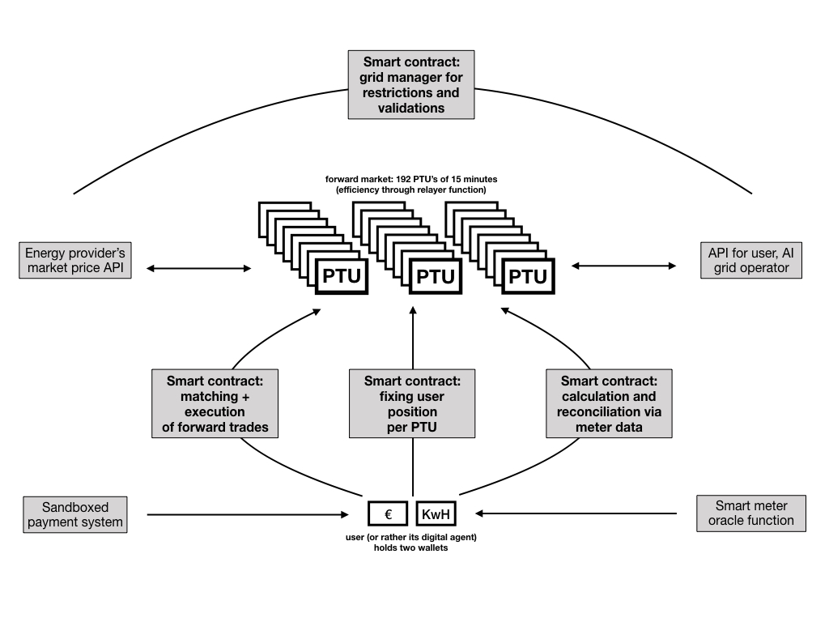

- Price discovery with accepted methodologies
  - For market participants to trade with confidence, they need to be guided by price methodologies that are widely accepted.
  - What we have done:
- Designed and modelled two (2) distributed pricing and market mechanisms maximising utilisation of renewables, incentivising flexibility of demand and supply.
- Price is the tool that aligns market participants’ interests. Prosumers/consumers achieve more competitive prices than grid pricing; grid operators achieve increased distributed grid balance; governments and society achieve greater decarbonisation.
- Data and Analytics to manage risk and capture opportunity
  - Market participants need a wealth of data to form trading views. Data will include historical pricing, forward curves, weather forecasts and actuals.
  - Analytics and modelling are needed to help interpret data for decision making.
  - What we have done:
- Consolidated/generated supporting data, analytics and models that help participants hedge and profit.
- This is the foundation to enable leading-edge outputs/performance from AI agents (see next point).
- Ongoing communication with market participants
  - Our markets today communicate with Platts Editors via phone or messaging, to exchange pricing and market information.
  - Likewise, market participants in distributed energy require ongoing communication.
  - In community energy markets, individuals and companies are the market participants; however they may not have the time or interest to trade energy. Energy management systems or smart devices can be enabled to trade on behalf of their owners.
  - What we have done:
- “Trader and Analyst in a Bot”; prototyped AI smart agents to work with IoT (Internet of Things) devices, for communication with markets, using secure protocols via cloud.
- These smart agents reduce the burden of trading on companies or individuals, by learning the client’s energy needs, analyzing market trends and forecasts to optimize energy usage, and trading accordingly.
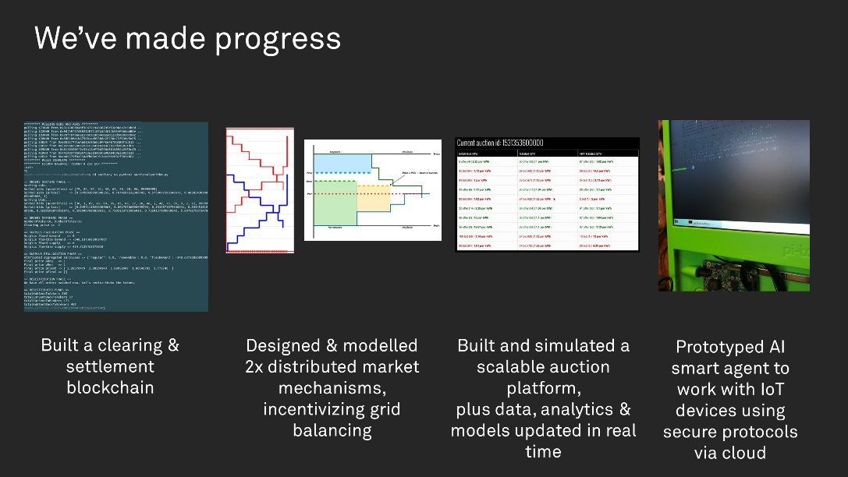

What differentiates our solution from others
From a positioning standpoint:
The industry has recognised the key problem as pricing and market inefficiency; Platts has unique expertise in facilitating efficient markets, Blocklab adds in-depth expertise on blockchain enabled trading and on smart grid solutions. To our knowledge, no one is approaching distributed energy market solutions (incl. peer-to-peer, aggregator and microgrid solutions) from a pricing efficiency angle. Others might have been in the power industry for as long as Platts, but they lack pricing expertise.
From a methodology standpoint:
Leading in market efficiency. Our market research shows that in terms of driving market efficiency, Platts’ and Blocklab’s joint pricing and market mechanism has one of the leading methodologies. Several frontrunners have focused on solving the problem of enabling community ‘peers’ to trade energy with each other, which does help them to find better prices but may not optimise market efficiency.
Integrating flexibility. Competitors mostly provide inflexible energy trading (like “market orders”) and flexibility trading (like “limit orders”) in separate markets. We have combined these into a single market.
Though the above holds true for the majority of competitors, they can and will go up the learning curve and potentially match Platts in terms of market know-how.
From a technology standpoint:
Consider the benefits from our technologies separately:
Blockchain:
- Fully secure trade in 192 forward market windows;

- High speed, highly efficient due to secure relayer;
- Smart contracts that rule all core components of a dynamic forward market;
- Integration with data pipeline and artificial intelligence;
- Independently functioning, regardless of user chooses to adopt AI trading agent.

AI trading agents minimise the burden of trading (optimising saving and profit-making) and energy management. In the absence of time and trading know-how, market participants are still assured of robust trading strategies and the ability to execute on those strategies.

We believe this combination of technologies allows us to achieve market efficiency and grid balancing (i.e. solving the multi-billion dollar problem) more quickly than otherwise. It also makes it easier for market participants to achieve their objectives.

Roadmap: deployment plan

March 2019: First distributed energy market
Status: Confirmed
Deploy at Port of Rotterdam, with 20-40 businesses trading within the community, behind a single grid connection.
Q3-Q4 2019: Second (and potentially third) distributed energy market
Status: Likely
Q3 2019 is the earliest we will deploy a second rollout, likely within Europe. Given typical timeframes for negotiations, potential regulatory checks etc, this might be in Q4 2019.

Respective contributions
Platts and Blocklab contribute an equivalent of EUR 250,000 respectively to the project in mainly in resource efforts (existing headcount or specifically funded for this project), and IP (details in Section 7).
Platts is contributing:
- Market expertise and pricing mechanisms
  - Intellectual property around pricing mechanisms (joint effort with Blocklab experts).
  - Intellectual property around analytics models (joint effort with Blocklab experts).
  - Resource bandwidth: Content and Analytics.
- Data science
  - Setting up data pipelines.
  - Building and training virtual AI trading agents to perform actions in a distributed energy market, representing consumers and businesses.
  - Modelling grid scenarios to train the AI trading agents.
  - Resource bandwidth: Data analyst, quantitative analyst, (incoming) data scientist.
- Use of Platts Data Lake
  - To house data needed by the project.
- UI/UX design
- Project management and business development

Blocklab is contributing:
- Expertise on smart grids, transitioning power markets and blockchain trading models.
- Design and development of blockchain technology.
  - Development team – full stack, blockchain, smart contracts
Blocklab is contributing a development team with blockchain and smart contract expertise, particularly in Ethereum which forms the basis of our pilot project.
  - [The following paragraph is pending revision by Blocklab; review is ongoing regarding additional resources needed]
Internet of Things / distributed systems engineer
Headcount to work across the IoT technology stack (device hardware, device software, communications, cloud platform, cloud applications). Ensuring that code executed brings about the intended physical energy flows.
- Physical site to implement our pricing mechanism
The Port of Rotterdam is owner and landlord of significant port-side real estate. In our pilot implementation site, they own all grid connections and every tenant’s smart meter. With the Port of Rotterdam’s signoff, we are able to gather relevant energy usage data and test our pricing mechanism locally with low risk.
- Project management and business development

IP generated

Jointly generated IP:
- Pricing and market mechanisms/methodology for energy trading within a microgrid (distributed energy grid), and from the microgrid to the national/main grid. Our market design has greater overall advantages for (market participants across) the industry, as compared to competing methodologies.
Unique objectives of our methodology include:
  - Optimising utilisation of renewables;
  - Optimising returns on battery storage;
  - Integrating flexibility (both demand and supply side) into pricing and markets – competitors typically have either inflexible or flexibility markets;
  - Integrating forward markets;

which ultimately maximise price and market efficiency, and grid balancing (see Section 9 for details).
Platts-generated IP:
- AI trading agents helping market participants to trade (make market analyses, trade decisions and execution).
  - As of now, these are proprietarily designed for use in distributed energy markets trading on Platts’ pricing mechanisms.
  - There is a possibility they can be redesigned to suit other markets, however this depends on differences between Platts-designed market and the former.
- Bespoke data and models for building and training the AI trading agents.
Blocklab-generated IP:
- Technical design and programming code representing jointly developed pricing and market mechanisms.
  - Where good technical design is key to ensuring market efficiency (timely and accurate matching and settlement).
  - The result is a functional marketplace, which enables market participants to register and trade efficiently.
  - Example of technical design:
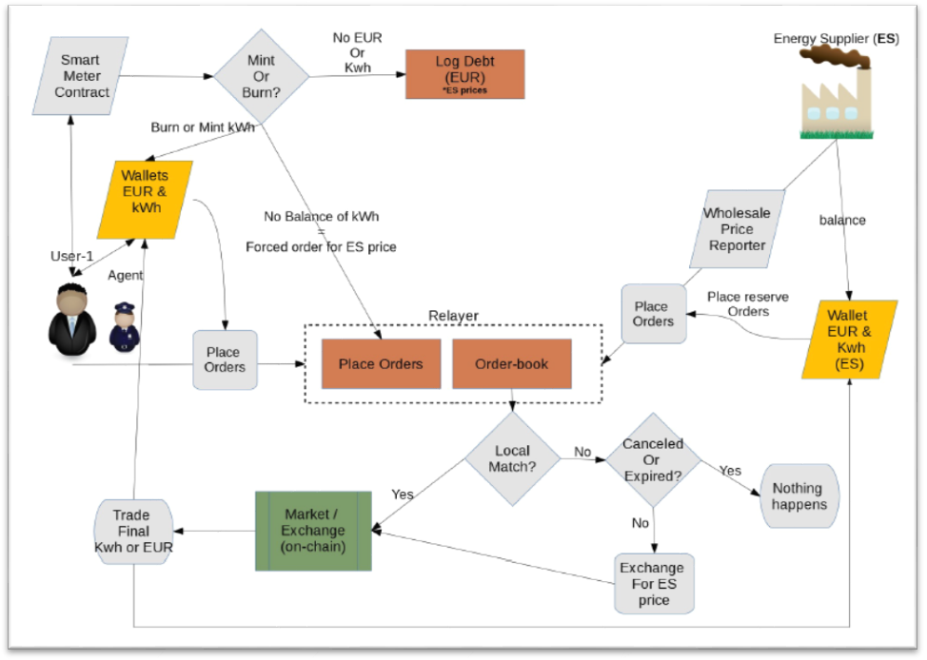

- Technical design and programming code facilitating mainly the market rules and customized hardware components.
- Energy usage data and transactional data of individual entities trading within the microgrid (expected from Q1 2019).

- Additional collaborators

We will need additional expertise in smart grids, hardware and security. These experts may come onto the project as consultants, employees/contractors or venture partners. Naturally, we expect there will be individual or co-generated IP from such collaboration.

Target objectives & success metrics
Broadly, success means achieving two things: market efficiency and scalability.

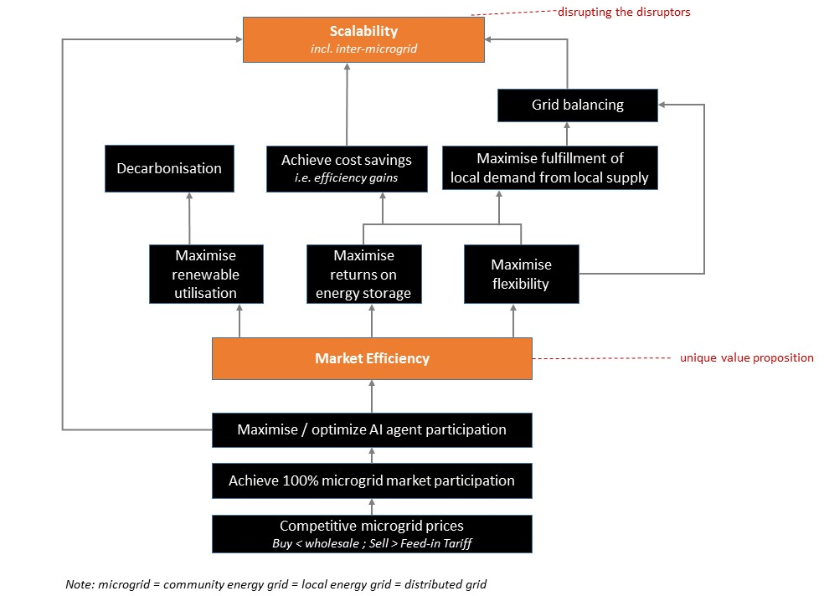

The underpinning objectives and metrics reflect these:
Due date | Objective - we want to… | Category | Metric Baseline | Metric Target | Metric Description
End Feb | Achieve AI agent trading success in virtual test environment | Develop AI capabilities | NA | positive, converged | All agents respectively reach positive savings (convergence point) when they are acting on unseen data
End Feb | Deploy blockchain technology for trading and settlement | Develop blockchain capabilities | 0 | 80 | # users that the market can successfully accommodate  (based on the market passing defined tests for that # users)
End Mar | Achieve 100% community market participation (as represented by agents; measure of adoption) | Pricing & market efficiency | 0 | 100 | % total agents participating, daily
End Mar | Maximise local grid balancing, i.e.  Maximise fulfillment of local energy demand from local energy supply | Pricing & market efficiency | 0 | 80 | % of total volume of trades which are fulfilled by local energy sources, daily, per agent  i.e. (local energy volume) / (local + wholesale energy volume)
End Mar | Maximise local grid balancing, i.e.  Maximise fulfillment of local energy demand from local energy supply | Pricing & market efficiency | 0 | 80 | % of total volume of trades which are fulfilled by local energy sources, daily, market overall  i.e. (local energy volume) / (local + wholesale energy volume)
End Mar | Achieve AI agent trading success in virtual test environment | Develop AI capabilities | NA | positive, converged | All agents respectively reach positive savings (convergence point)
End Mar | Deploy blockchain technology for trading and settlement | Develop blockchain capabilities | 0 | 100 | % transaction throughput successfully settled timely  (where 'timely' = within 5 minutes after trading interval ends)
End Mar | Deploy blockchain technology for trading and settlement | Develop blockchain capabilities | NA | ≤ 10 | # seconds to refresh relayer  (assumption: 10 seconds ensures relayer to update the chain on time)
End Apr | Achieve market efficiency gains (cost savings) | Pricing & market efficiency | NA | 80 | % total volume of BUY (bid) trades which are more competitively priced than wholesale
End Apr | Achieve market efficiency gains (cost savings) | Pricing & market efficiency | NA | 80 | % total volume of SELL (offer) trades which are more competitively priced than wholesale
Q4 2019 | Scale to new markets | Growth | 0 | ≥ 2 | Deploy our solution in new locations.

